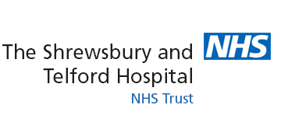

Application Form for Young Volunteer Scheme
Sixth Form Students at Newport Girls’ High School have a unique opportunity of being able to volunteer at the Princess Royal Hospital Telford or Royal Shrewsbury Hospital as part of the NHS Young Volunteers Scheme. The scheme is a six to twelve month placement, of three to four hours per week, at either hospital. At the point of application you are asked for any specialist area which you would like to pursue as the experience you have will be guided by this. All applications should be printed and handed to Mrs Gill or emailed (k.gill@nghs.org.uk).
Name
Address
Date of Birth
A level subject choices | 1.  2.  3.
Extra-curricular interests and responsibilities

In the 2018-19 recruitment year there will be two intakes; the first in Sept/Oct, the second in Feb/March. Please indicate your preference below:
Sept/Oct €
Feb/Mar €
Either €

Please respond to the following questions:
- Why are you interested in applying for this opportunity? What will you gain?

- Which particular area of health are you interested in/what career path are you looking to pursue?

- If you were successful in gaining a place on the scheme how would you travel to the hospitals?

- What experience have you already had within the healthcare sector?

- What particular skills do you already possess which you feel make you suitable for the placement?

- In summary, why should you be selected?

Please confirm here with a tick that by applying for the scheme you are committed to a six month scheme which will involve 3-4 hours per week of your time. Places are limited and this commitment is essential to being considered.

Thank you for completing this application form.

